Lab Assignment 4

# **Ques 1.** Write a shell script to display numbers between 1 to 100 using while loop.

i=1

while [ $i -le 100 ]

do

    echo $i

    i=`expr $i + 1`

done

# **Output**

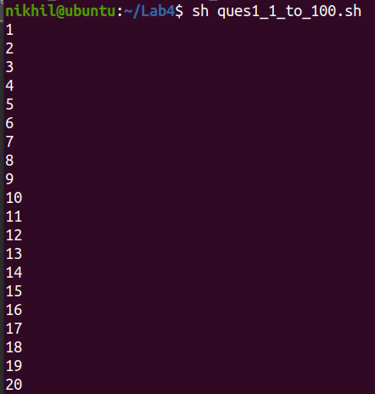

# **Ques 2.** Input a 3 digit number and display the sum of digits.

echo "Enter a Number"

read num

sum=0

while [ $num -gt 0 ]

do

mod=`expr $num % 10`

sum=`expr $sum + $mod`

num=`expr $num / 10`

done

echo $sum

# **Output**

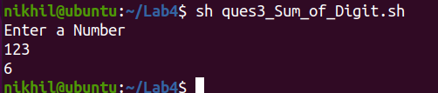

# **Ques 3.** Input a number and check number is palindrome or not.

# 

echo "Enter a Number : "

read a

sum=0

num=$a

while [ $num -gt 0 ]

do

d=`expr $num % 10`

sum=`expr $sum \* 10 + $d`

num=`expr $num / 10`

done

if [ $sum -eq $a ]

then

echo "Palindrome Number"

else

echo "Not a Palindrome Number"

fi

# **Output**

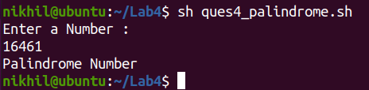

# **Ques 4.** Write a shell Script to input a number and check number is armstrong or not.

# 

echo "Enter the number"

read number

revNumber=0

loopCounter=$number

while [ $loopCounter -gt 0 ]

do

lastDigit=`expr $loopCounter % 10`

revNumber=`expr $revNumber + $lastDigit \* $lastDigit \* $lastDigit`

loopCounter=`expr $loopCounter / 10`

done

if [ $number -eq $revNumber ]

then

echo "Your number is Armstrong Number"

else

echo "Your number is not Armstrong Number"

fi

# **Output**

# 

# **Ques 5.** Find the Fibonacci series in n terms.

echo "Enter numbers of terms:”

read n

nextTerm=1

term=0

echo "$term"

echo "$nextTerm"

while [ $n -gt 0 ]

do

sum=`expr $term + $nextTerm`

echo "$sum"

term=`expr $nextTerm`

nextTerm=`expr $sum`

n=`expr $n - 1`

done

# **Output**

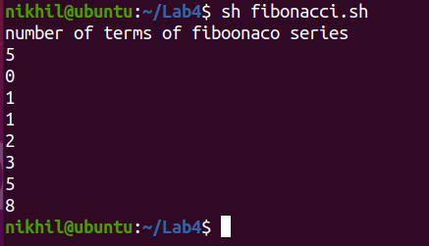

# **Ques 6.** Write a shell script to display the prime no between ranges.

echo "Enter the range num1 and num2:"

read num1 num2

echo "Given range from user is $num1 anf $num2 "

echo "Prime Numbers are:"

while [ $num1 -le $num2 ]

do

i=2; flag=1

while [ $i -lt $num1 ]

    do

        if [ `expr $num1 % $i` -eq 0 ]

        then

            flag=0

            break

        else

            i=`expr $i + 1`

        fi

    done

    if [ $flag -eq 1 ]

    then

        echo $num1

    fi

    num1=`expr $num1 + 1`

done

# **Output**

# **Ques 7.** Write a shell script to display the grade system of KIIT University based on total marks secured by a student in a semester. Assume marks are integer values. Use switch-case statement.

# The grade is calculated is as follows:

Marks Grade

90 to 100 O

80 to 89 E

70 to 79 A

60 to 69 B

50 to 59 C

40 to 49 D

< 40 F

echo "Enter total marks of students"

read n

case $n in

100)

echo "O" ;;

9[0-9]) echo "O" ;;

8[0-9])echo "E" ;;

7[0-9]) echo "A" ;;

6[0-9]) echo "B" ;;

5[0-9]) echo "C" ;;

4[0-9]) echo "D" ;;

*)

echo "F";;

esac

# **Output**

